Chapter 4: Understanding and Comparing Distributions

1. **Boxplot:**
2. Open the data file (Mugs.csv). In this file, there are two variables which are difference and container.
3. Select the first column (difference), then select the **Insert** tab $⟹$ I**nsert Statistic Cart $⟹$ Box and Whiskers**.

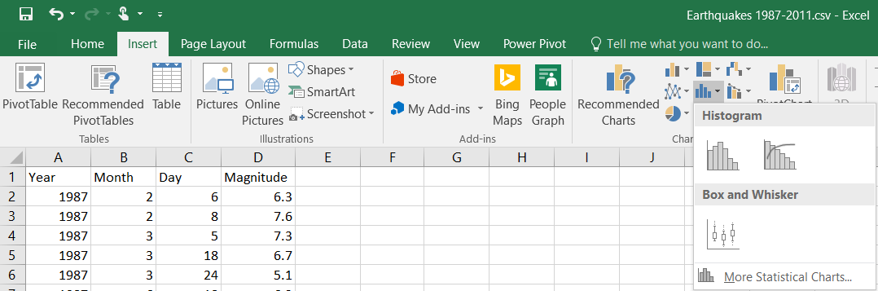

1. The result is

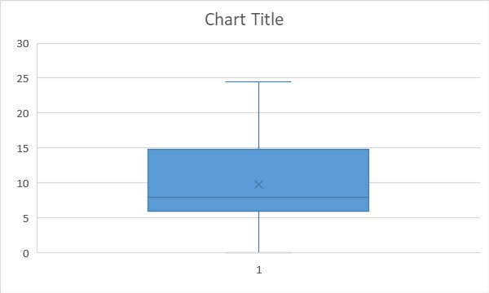

1. Click on the graph using the right mouse button, then click on **Select Data** and **Select Data Source** box will appear, select **Edit** and **Axis Labels** box will appear, click on **Axis label range**, then select the second column (container) without the label and click **OK**, the **Select Data Source** box will appear again, click **OK**.

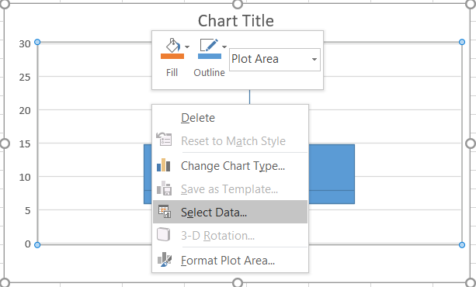

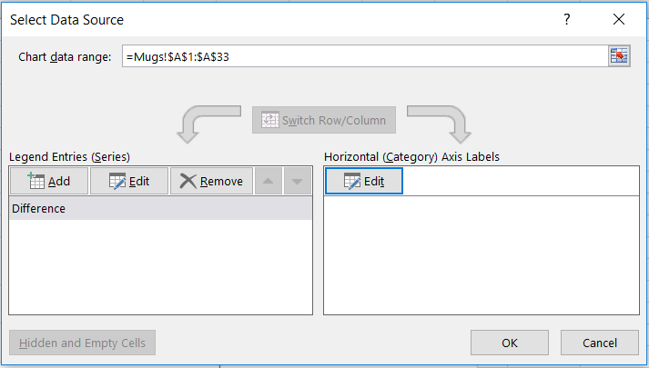

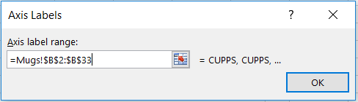

1. The result is

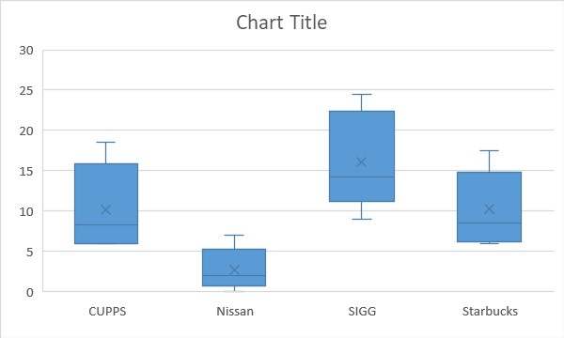

1. **Timeplot:**
2. Open the data file (WindSpeed 1.csv). In this file, there are four variables which are month, day, obs (the order), and wind speed.
3. Select the third and forth column (obs and wind speed). Select the **Insert** tab $⟹$**Insert Scatter Cart (X, Y) or Bubble Chart $⟹$ Scatter**.

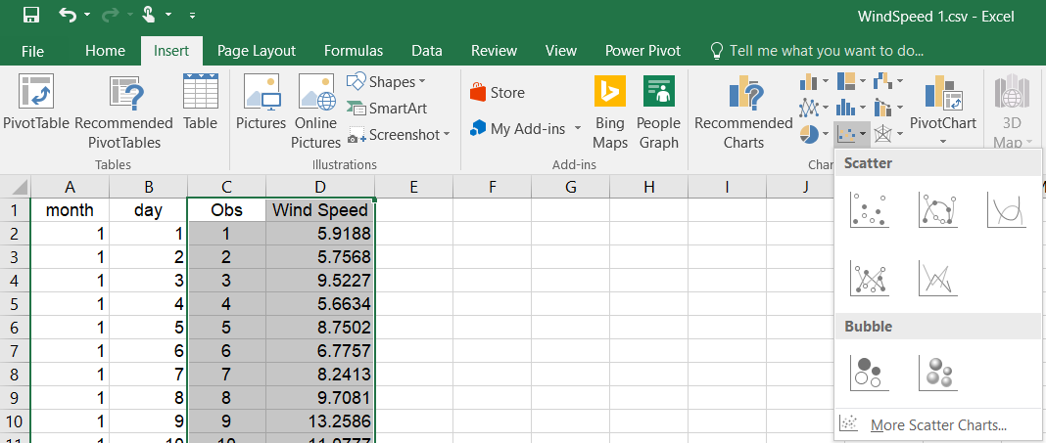

1. The result is

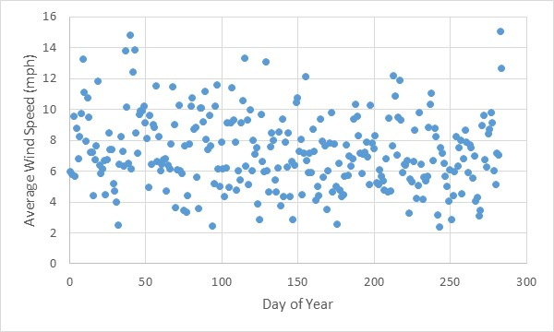

1. We often see the timeplots drawn with all points connected and to do that, select the **Insert** tab $⟹$ I**nsert Scatter Cart (X, Y) or Bubble Chart $⟹$ Scatter with Smooth Lines and Markers**.



1. The result is

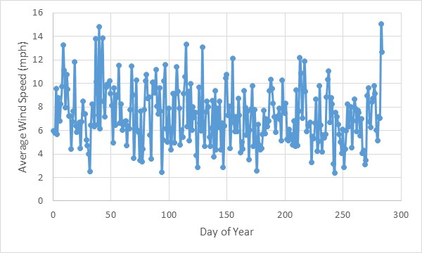

1. To smooth the curve, click on any point in the graph using the right mouse button, then select **Add Trendline** and **Forma Trendline** box will appear. Select the appropriate **Trendline obtions**, here we select **polynomial** with **degree 3** (cubic).

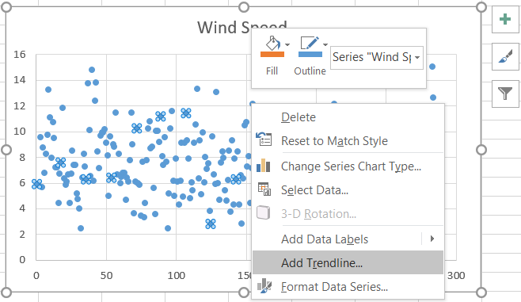

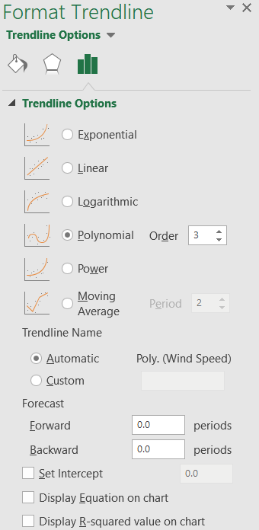

1. The result is

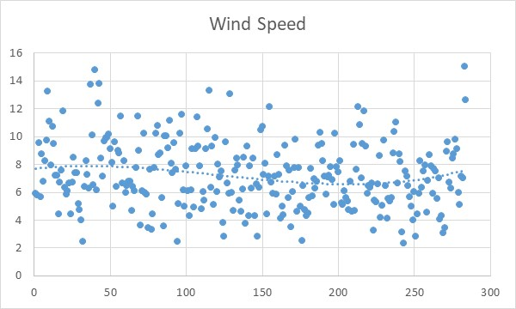

1. We can make the smooth curve solid with different color by select **Fill & Line** in **Format Trendline**, then select **Dash type** and click on **Solid**, and select any **color**.

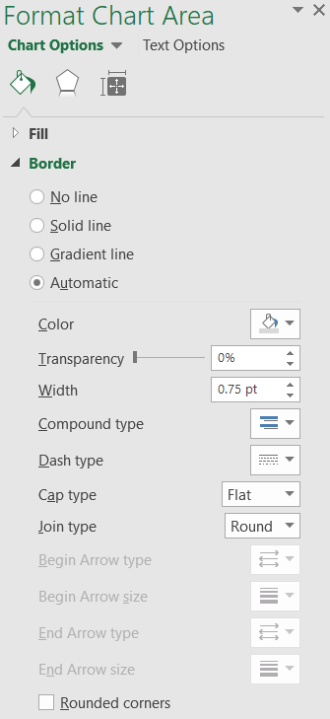

1. The result is

